Synchronize Customers with Accounts
- Navigate to Dataverse Connection Setup and select Run full synchronization.
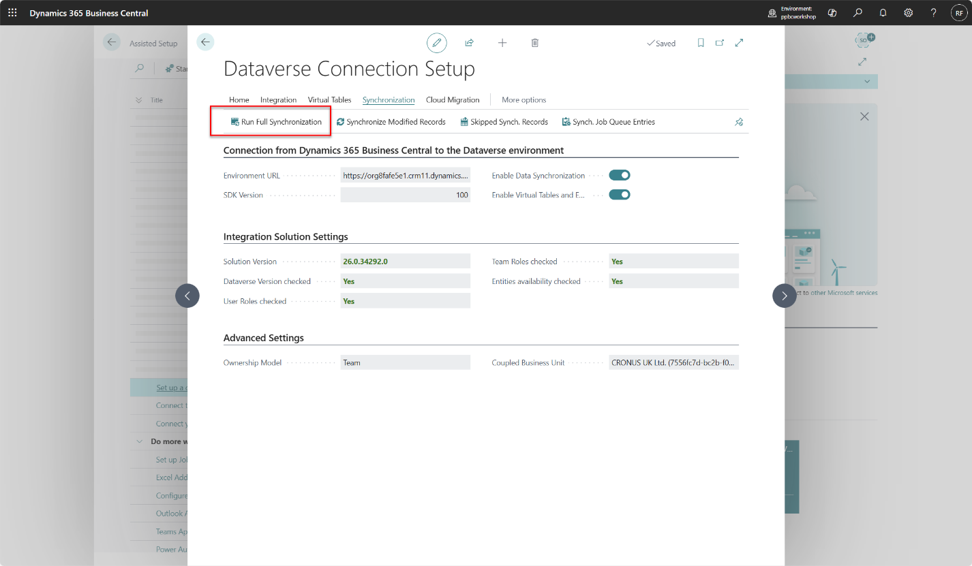
- Select Sync all to synchronize all object.
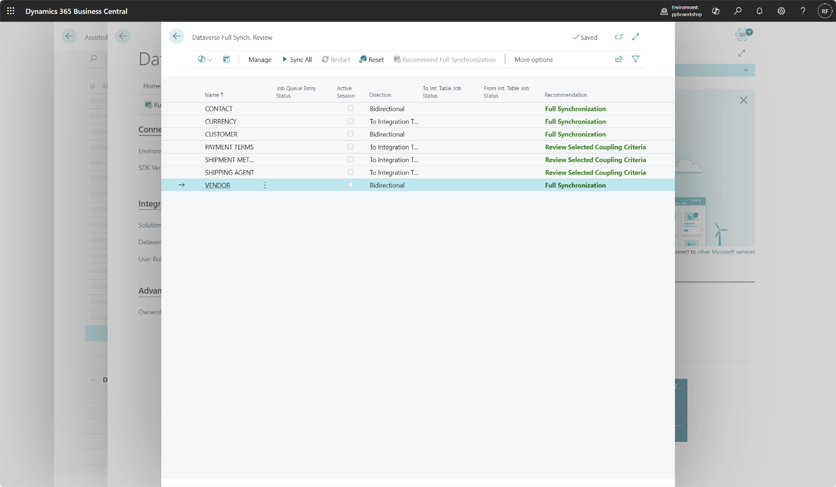
- Confirm that you want to synchronize all records.
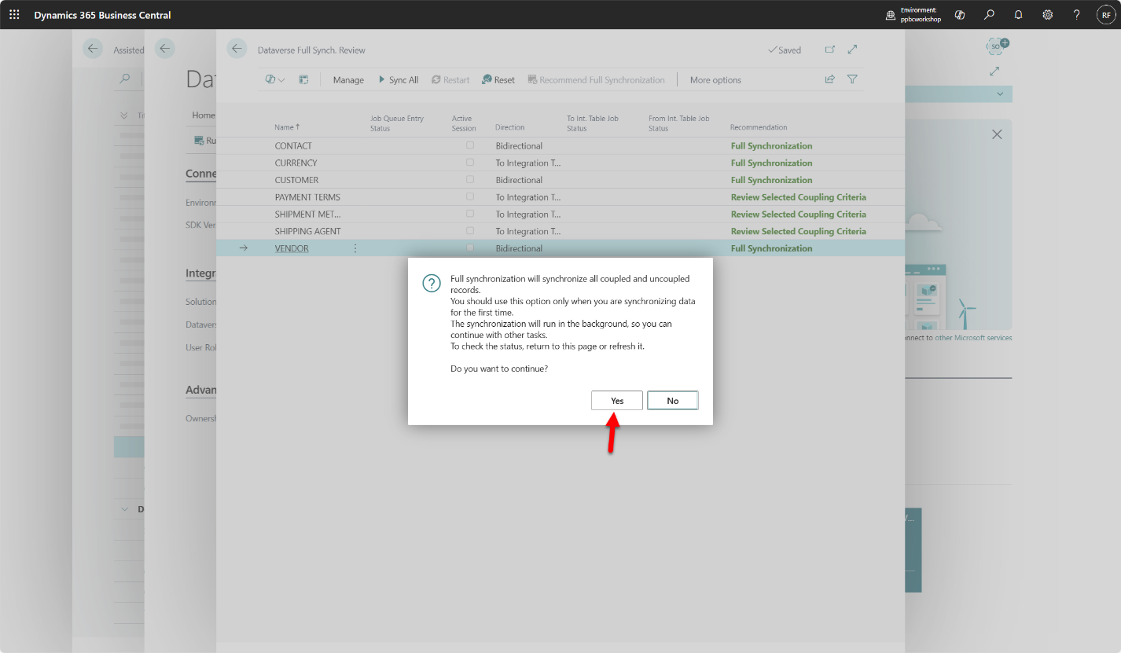
- After a few minutes all tables will be synchronized and coupled with Dataverse.
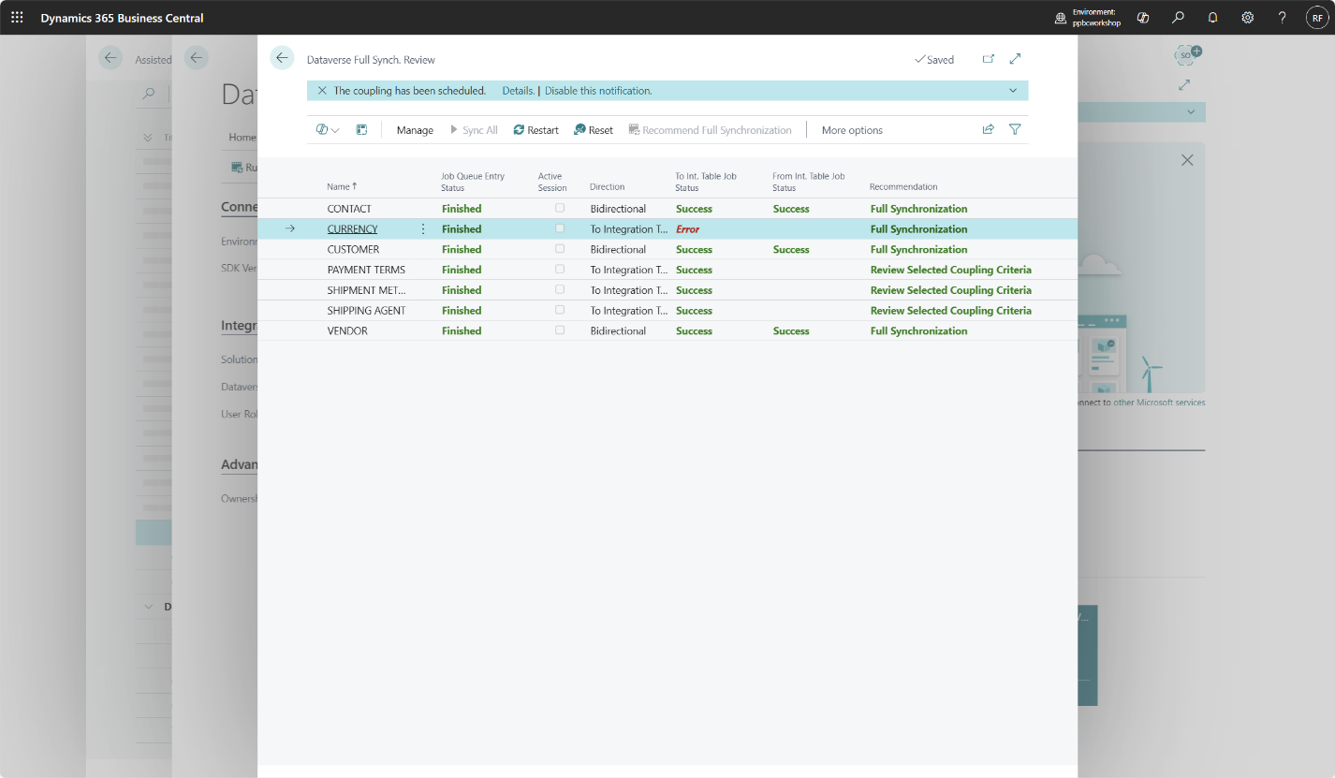
- Navigate to Customer Card and sync changes to dataverse.
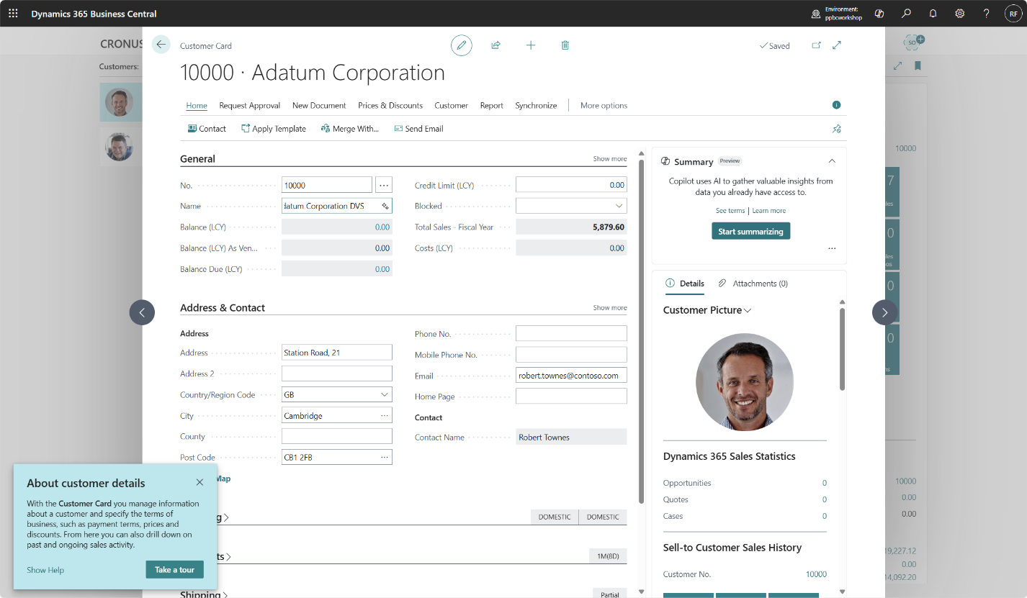
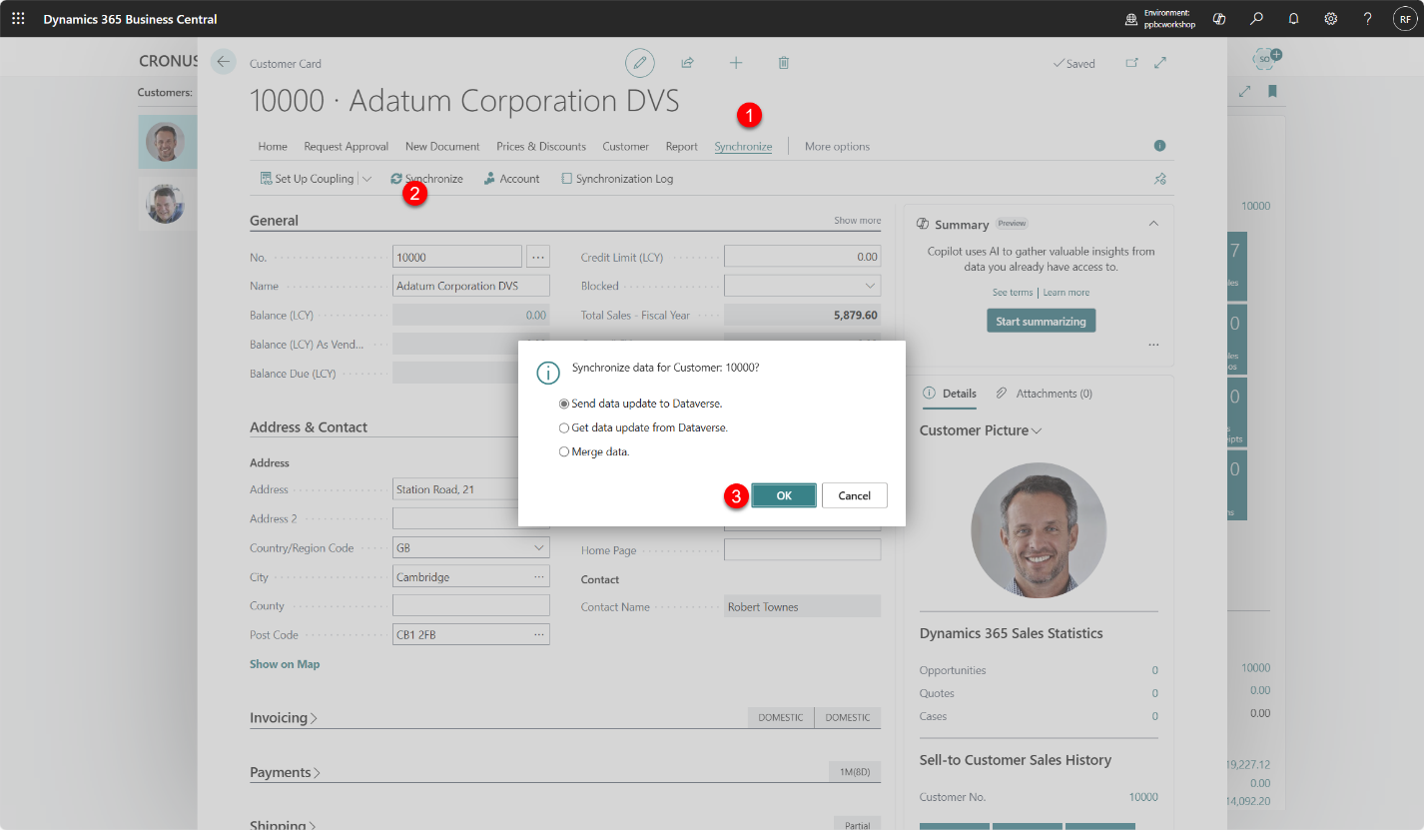
- Check the results in Dataverse account table.
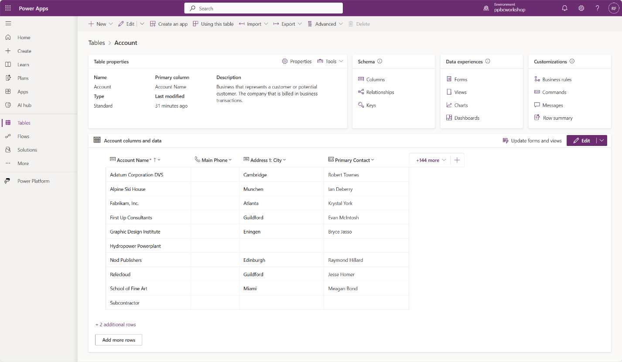
- Navigate to Dataverse Connection Setup > Available Virtual Tables
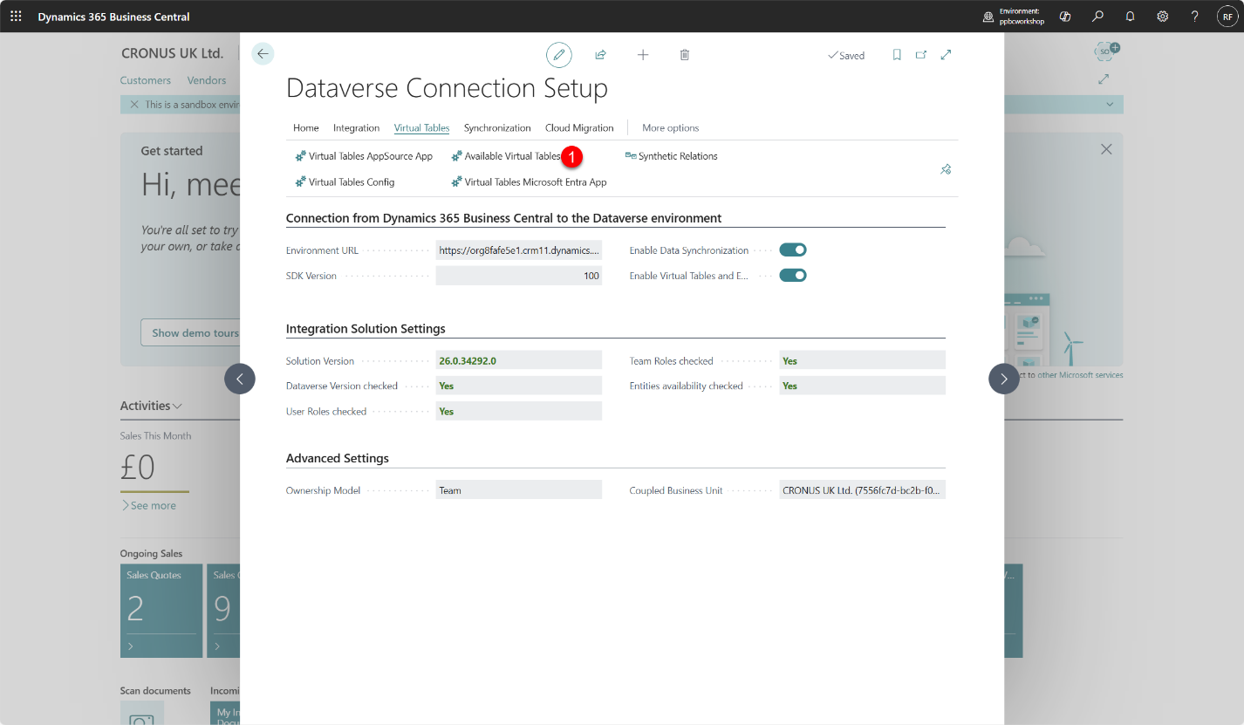
- Find vendor virtual table and enable it.
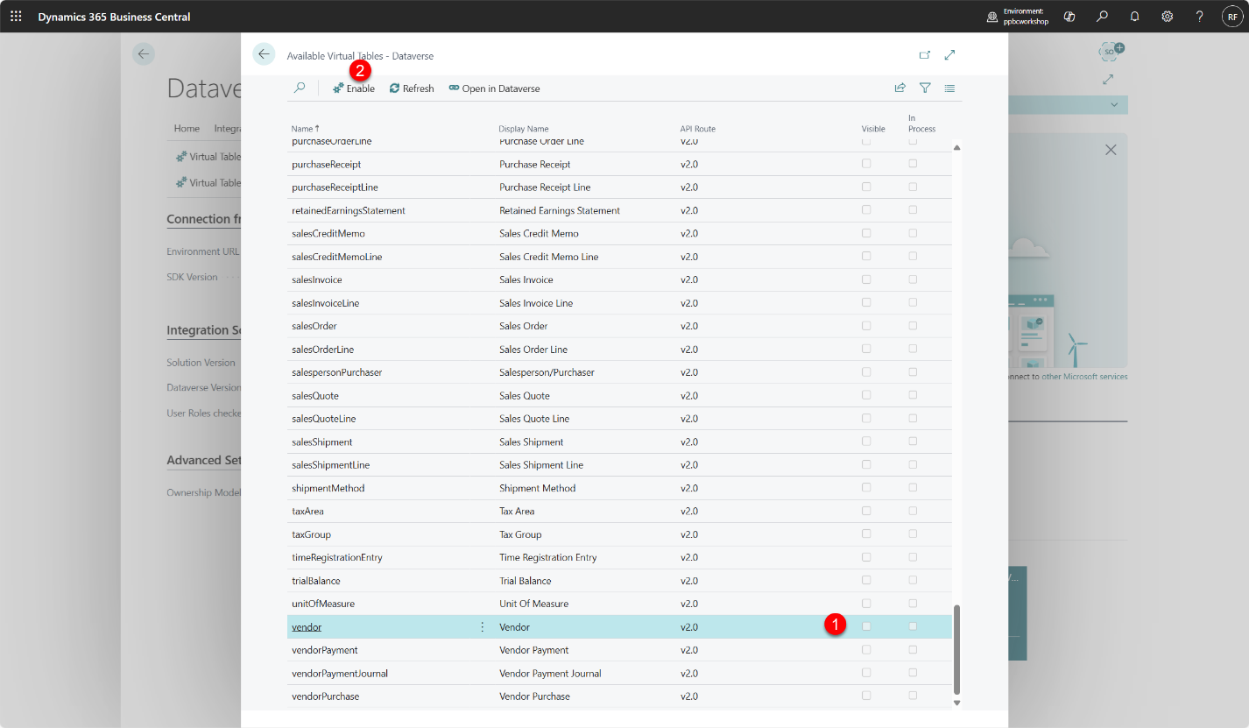
- Vendor table will change status and you will find checkmark in field In Process.
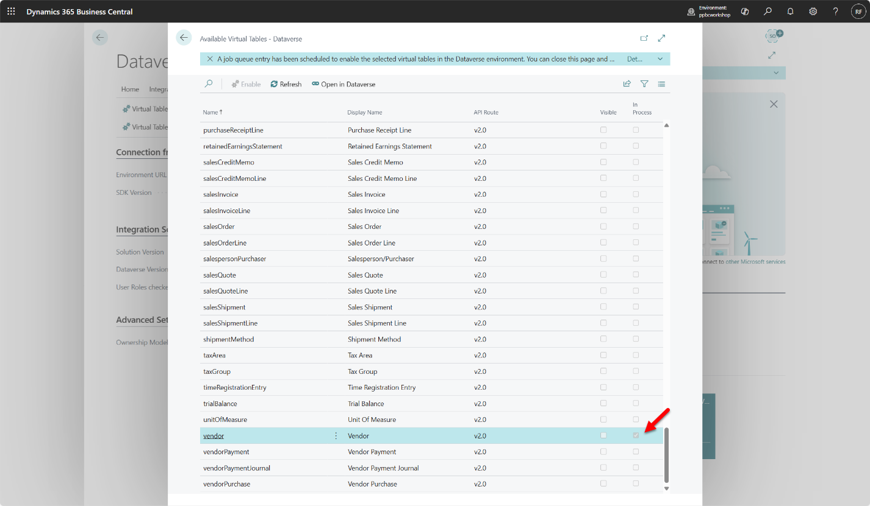
- When virtual table is available checkmark will be visible in field Visible.
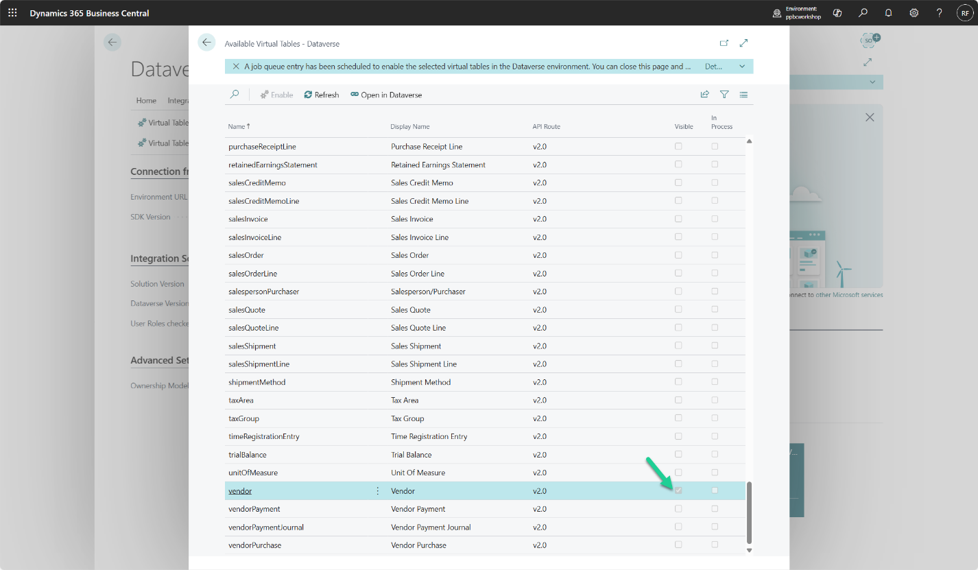
- Navigate to make.powerapps.com and in Tables section find Vendor table and explore data in Vendor table
